**Amrita Vishwa Vidyapeetham**

**Amrita School of Engineering, Coimbatore**

**Department of Computer Science and Engineering**

**Topic: MIPS ALP using QtSPIM**

**--------------------------------------------------------------------------------------------------------------------------**

**Sub Code: 19CS211 Sub Title: COA**

**Roll No: CB.EN.U4CSE19453 Name: R.ABHINAV**

**Lab Evaluation No: MIPS Date: 03-05-2021**

1. **Write a MIPS ALP to find the minimum and maximum elements in an array and also find their position (5 Marks).Size and elements in the array can be decided by you.**

**Code :**

.text  
 .globl main  
  
main:  
 la $a0, ask #ask user for integer thats going to be the size of the array  
 li $v0, 4  
 syscall  
  
 li $v0, 5 #store that int  
 syscall  
 move $t1,$v0 #size of my array stored in $t1  
  
 la $t0, array #load address of our array  
 li $t2, 0 #counter = 0  
 lw $t3,($t0) #initialize min = array[0]  
 lw $t4,($t0) #initialize max = array[0]  
  
  
while:  
 la $a0, intask #ask user for integer  
 li $v0, 4  
 syscall  
  
 li $v0, 5 #store that int  
 syscall  
 sw $v0, ($t0) #store that int in the array  
  
  
end: add $t0, $t0, 4 #increment the array to the next index  
 add $t2, $t2, 1 #increment the counter by 1  
 blt $t2, $t1,while #branch to while if counter < size of array  
  
endw:  
 la $a0,display # Display "Array is: "  
 li $v0,4   
 syscall  
  
 li $t0, 0 # initilize array index value back to 0  
 li $t2, 0 # initial size counter back to zero  
 la $t0, array # load address of array back into $t0  
  
 sprint:  
 lw $t6,($t0) #load word into temp $t2  
 move $a0, $t6 #store it to a safer place  
 li $v0, 1 #print it out  
 syscall  
  
 la $a0,space # Display " "  
 li $v0,4   
 syscall  
  
 add $t0, $t0, 4 #increment the array to the next index  
 add $t2, $t2, 1 #increment the counter by 1  
  
 blt $t2, $t1,sprint #branch to while if counter < size of array  
  
 li $t2, 0 # initial size counter back to zero  
 la $t0, array # load address of array back into $t0  
 add $t0, $t0, 4 #increment the array to the next index  
 add $t2, $t2, 1 #increment the counter by 1  
  
  
 loop: lw $t8,($t0) # t8 = next element in array  
 bge $t8, $t3, notMin #if array element is >= min goto notMin  
 move $t3,$t8 #min = array[i]  
 j notMax  
  
 notMin: ble $t8,$t4, notMax #if array element is <= max goto notMax  
 move $t4,$t8 #max = array[i]  
  
 notMax: add $t2,$t2,1 #incr counter  
 add $t0,$t0, 4 #go up in index  
 blt $t2, $t1,loop #if counter < size, go to loop  
  
 eprint:  
 la $a0,nextline # Display "\n"  
 li $v0,4   
 syscall  
  
 la $a0,min # Display "min number is "  
 li $v0,4   
 syscall  
  
 move $a0, $t3 #displays min number in array  
 li $v0,1  
 syscall  
  
 la $a0,nextline # Display "\n"  
 li $v0,4   
 syscall  
  
 la $a0,max # Display "max number is "  
 li $v0,4   
 syscall  
  
 move $a0, $t4 #displays max number in array  
 li $v0,1  
 syscall  
  
 li $v0,10 # End Of Program  
 syscall   
  
.data  
array: .space 100  
ask: .asciiz "Size of the Array: "  
intask: .asciiz "Enter an Integer: "  
min: .asciiz "The minimum number is: "  
max: .asciiz "The maximum number is: "  
display: .asciiz "Array: "  
space: .asciiz " "  
nextline: .asciiz "\n"

**Data Segment:**

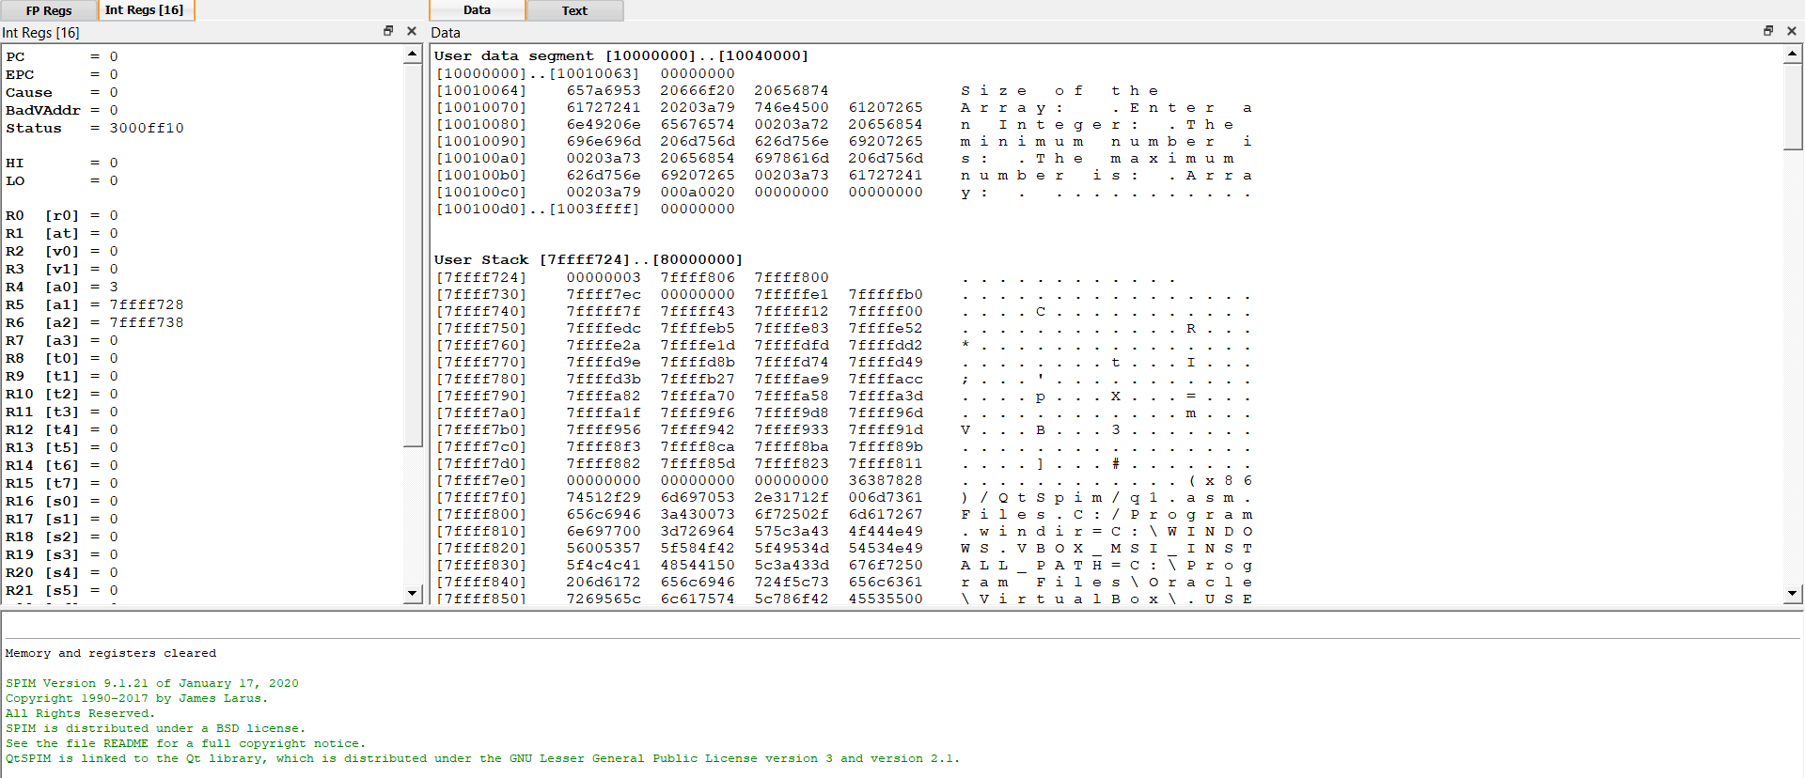

**Text Segment :**

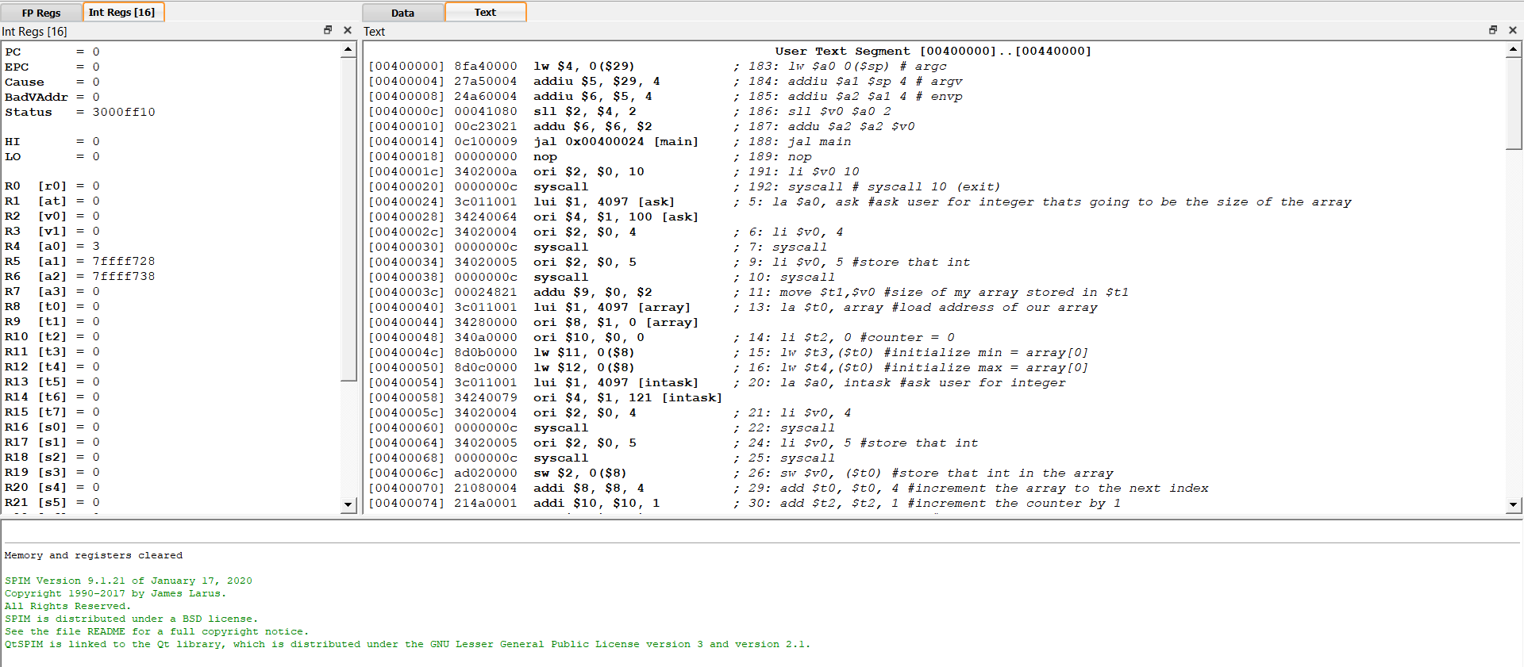

**Output:**

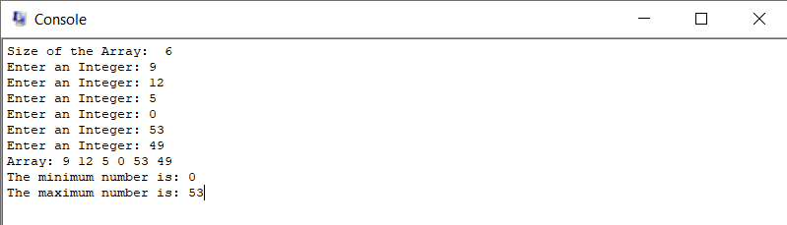

1. **Write a MIPS ALP to find the average of various elements in a array and append the average value at the end of the array. Size and elements in the array can be decided by you.**

**Code :**

.data  
 array: .word 10, 2, 9, 14, 19, 25  
 length: .word 6  
 sum: .word 0  
 average: .word 0  
 avgString: .asciiz "Average: "  
 arrayString: .asciiz "\nArray: "  
 space: .asciiz " "  
  
.text  
  
main:  
 la $t0, array #Base address  
 li $t1, 0 #i=0  
 lw $t2, length #$t2 = n  
 li $t3, 0 #sum = 0  
  
 sumLoop:   
 lw $t4, ($t0) #$t4 = arr[i]  
 add $t3, $t3, $t4 #sum += arr[i]  
   
 add $t1, $t1, 1 #i++  
 add $t0, $t0, 4 #Increment array address  
  
 bne $t1, $t2, sumLoop #i != n continue  
  
 sw $t3, sum  
   
 #Average  
 div $t5, $t3, $t2 #$t5 = sum/n  
 sw $t5,average  
  
 #Print string system call  
 la $a0, avgString  
 li $v0, 4  
 syscall  
  
 #Print integer system call  
 li $v0, 1  
 add $a0, $t5, 0  
 syscall  
  
 #Add integer to array  
 sw $t5, ($t0)  
 add $t2, $t2, 1 #n+=1  
  
 #Print string system call  
 la $a0, arrayString  
 li $v0, 4  
 syscall  
  
 la $t0, array #baseaddress  
 li $t1, 0 #i=0  
 displayLoop:  
 #Print integer system call  
 li $v0, 1  
  
 lw $t4, ($t0)  
 add $a0, $t4, 0  
 syscall   
  
 #Print space to screen  
 la $a0, space  
 li $v0, 4  
 syscall  
   
 add $t1, $t1, 1 #i++  
 add $t0, $t0, 4 #Increment array address  
 bne $t1, $t2, displayLoop  
  
 #Exit program  
 li $v0, 10  
 syscall

**Data Segment:**

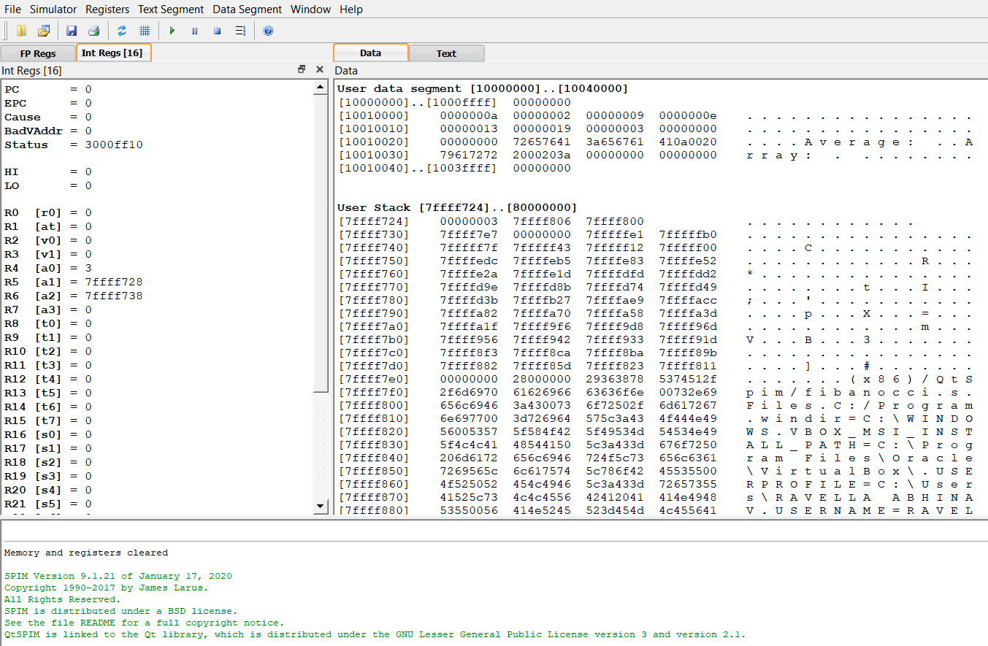

**Text Segment :**

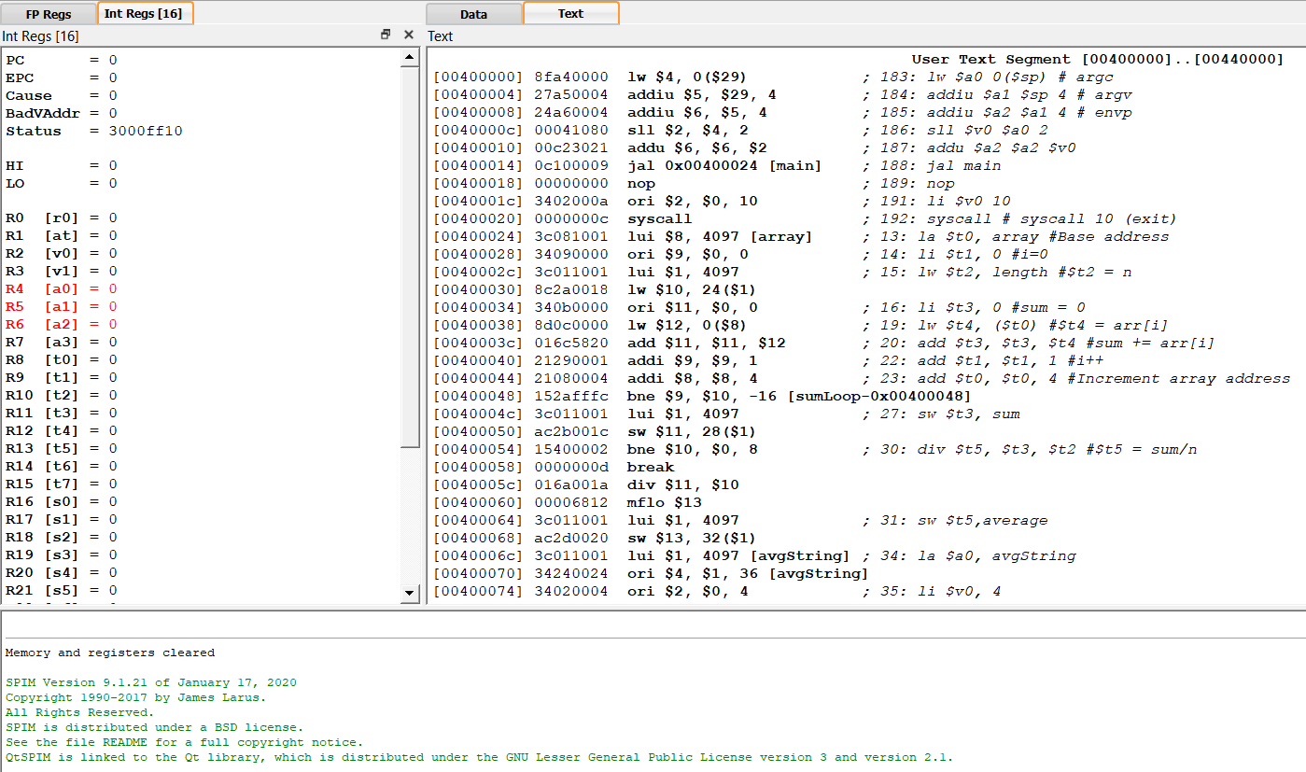

**Output:**

Input Array : 10, 2, 9, 14, 19, 25

